**EXPERIMENT-7**

# R-2R ladder D-A Converter using OP-AMP.

-----------------------------------------------------------------------------------------------------------------------------------------------------------------------------------------------------------------------------------------------------------------------------------------------------------------------------------------------

1. To Design a R-2R ladder D-A Converter using OP-AMP.
2. To Verify the functionality of above circuits.
3. **Aim:**
4. **Specification:** circuit uses LM741 IC
5. **Apparatus**

**Hardware:**

1. Resistors (1k $Ω$, 2k $Ω$)
2. Voltmeter
3. LM 741
4. Regulated Power Supply
5. Bread board
6. **Theory:**

**Operational Amplifier as a DAC**

An operational amplifier (op-amp) can be configured to function as a Digital-to-Analog Converter (DAC), a device that converts digital signals (discrete levels) into analog signals (continuous waveform). This functionality is achieved by using a network of resistors in conjunction with the op-amp to create weighted sums of the digital inputs, translating them into a proportional analog voltage.

1. **Procedure:**
2. Connect the circuit as per the circuit diagram
3. Apply input as per the requirements and observe the outputs.
4. Observe the outputs of R-2R ladder DAC using a voltmeter.
5. Note the outputs and compare the theoretical values with the practical values and also note the saturation values of op-amp.

**Design:**

$$Vout=[\frac{−R_{f}}{R}]∗(8∗VD + 4∗VC + 2∗VB + 1∗VA)/ 2^{4}$$

1. **DAC Conversions:**

|  |  |  |  |  |  |
| --- | --- | --- | --- | --- | --- |
| **DIGITAL INPUTS** | | | | $V_{out}$**EXPRESSION** | $$V_{out}$$ |
| **D** | **C** | **B** | **A** | **(8*VD + 4*VC + 2*VB + 1*VA)/ $2^{4}$** | **In Volts** |
| 0 | 0 | 0 | 0 | (0*5 + 0*5 + 0*5 + 0*5)/16 | 0 |
| 0 | 0 | 0 | 1 | (0*5 + 0*5 + 0*5 + 1*5)/16 | 0.3125 |
| 0 | 0 | 1 | 0 | (0*5 + 0*5 + 2*5 + 0*5)/16 | 0.625 |
| 0 | 0 | 1 | 1 | (0*5 + 0*5 + 2*5 + 1*5)/16 | 0.9375 |
| 0 | 1 | 0 | 0 | (0*5 + 4*5 + 0*5 + 0*5)/16 | 1.25 |
| 0 | 1 | 0 | 1 | (0*5 + 4*5 + 0*5 + 1*5)/16 | 1.5625 |
| 0 | 1 | 1 | 0 | (0*5 + 4*5 + 2*5 + 0*5)/16 | 1.875 |
| 0 | 1 | 1 | 1 | (0*5 + 4*5 + 2*5 + 1*5)/16 | 2.1875 |
| 1 | 0 | 0 | 0 | (8*5 + 0*5 + 0*5 + 0*5)/16 | 2.5 |
| 1 | 0 | 0 | 1 | (8*5 + 0*5 + 0*5 + 1*5)/16 | 2.8125 |
| 1 | 0 | 1 | 0 | (8*5 + 0*5 + 2*5 + 0*5)/16 | 3.125 |
| 1 | 0 | 1 | 1 | (8*5 + 0*5 + 2*5 + 1*5)/16 | 3.4375 |
| 1 | 1 | 0 | 0 | (8*5 + 4*5 + 0*5 + 0*5)/16 | 3.75 |
| 1 | 1 | 0 | 1 | (8*5 + 4*5 + 0*5 + 1*5)/16 | 4.0625 |
| 1 | 1 | 1 | 0 | (8*5 + 4*5 + 2*5 + 0*5)/16 | 4.375 |
| 1 | 1 | 1 | 1 | (8*5 + 4*5 + 2*5 + 1*5)/16 | 4.6875 |

1. **Simulation Observation:**

**Case I: for 0001 combination:**

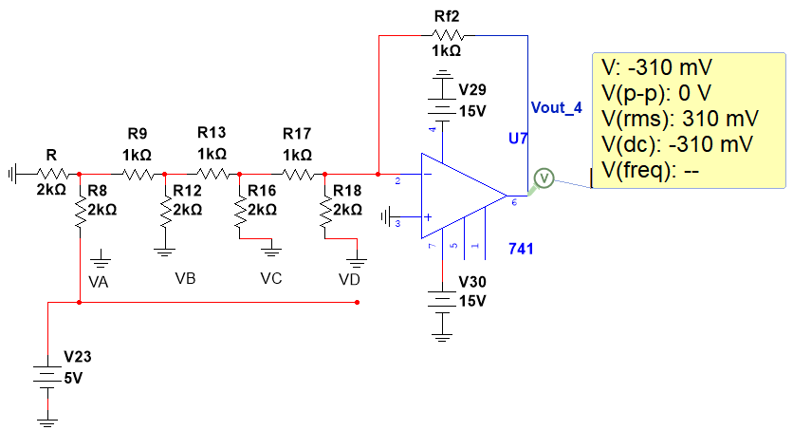

**CONCLUSION:**

In conclusion, an R-2R ladder Digital-to-Analog Converter (DAC) for a 4-bit input accurately converts digital signals into corresponding analog voltages. When the input binary code is 0001, the DAC produces an output voltage that represents the smallest possible increment above zero, corresponding to 1/16th of the reference voltage (V_ref) for a 4-bit system. This precision and linearity make the R-2R ladder DAC a reliable and efficient choice for applications requiring digital-to-analog conversion, such as audio processing, signal generation, and instrumentation.

**Case II: for 1111 combination:**

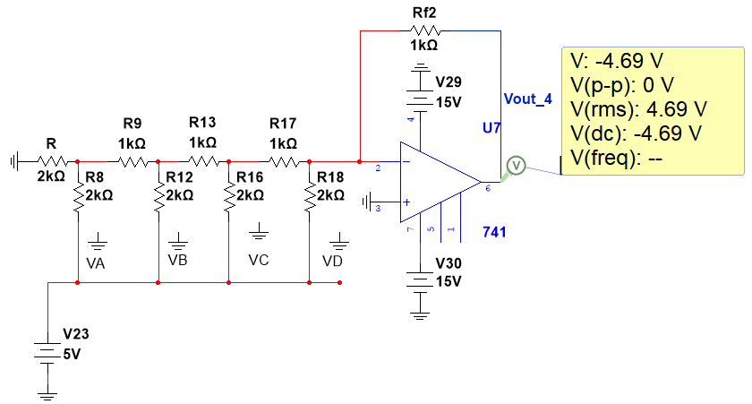

**CONCLUSION:**

From the above discussion, we can conclude that an R-2R ladder Digital-to-Analog Converter (DAC) effectively converts a 4-bit binary input into an analog output voltage. When the input is set to 1111 (binary), the DAC produces an output voltage that corresponds to the maximum value of the input range. The R-2R ladder configuration ensures precise and linear conversion due to its repetitive structure of resistors, making it an essential component in digital signal processing, data acquisition systems, and various applications requiring accurate digital-to-analog conversion.

1. **Result:**

Hence, we have designed, implemented and verified R-2R Ladder DAC using OP-AMP [LM741].

Signature of the Faculty